**Instructions for annotating “linked” detections**

Aaron Thode

August 2014

This document explains how to load and edit annotations for linked files in Ulysses, formerly known as “All File Specgram Viewer”. Acoustic files from two recorders are considered “linked” if the acoustic recorders were deployed close enough together such that a single bioacoustic “event” (e.g. a whale call) can be detected on both instruments. The linking features in Ulysses allow one to link annotations describing the same event between annotation files, and thus annotate a single event simultaneously. As of now, only files that end with the ‘GSI’ extension have this feature. GSI stands for “Greeneridge Sciences Incorporated,” and are files from a particular recorder known as a DASAR**ref**. DASARs are deployed in groups of seven along triangular grids known as “Sites”. The southernmost recorder is labeled “A,” and the northernmost is “G”. DASARs are deployed 7 km apart.

Linking annotation controls and link display

If a GSI file is loaded into Ulysses, the following new controls—“link up” and “link down” appear:

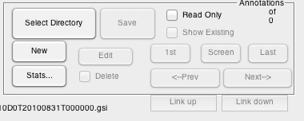

To begin, load a GSI file, select “update,” and then load an annotation file by hitting “Select Directory”. Eligible annotation files will have the keyword “East,” “West,” or “Center” in them. Hit “Screen” to move to the nearest annotation. In the following examples, I will be starting with S510D0T20100831T000000.gsi, or DASAR D from Site 5 during 8/31/2010. One GSI file covers one day.

Figure 1 shows how a linked annotation is displayed, if one hits the “Screen” button after loading this file. In addition to the regular “Annotation detail” window, a new window appears: a map of the location of a call. Each red triangle represents an acoustic recorder that is linked to the current annotation. Each blue line represents a bearing to the call, as detected by a particular recorder. A thick blue line indicates the bearing of the call currently visible on the screen. As is the case for a regular annotation, the current annotation should be highlighted by a pink box, as can be seen in Fig.1 .

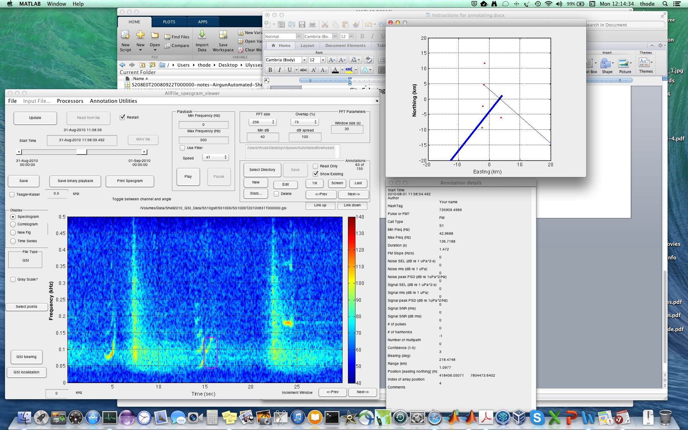

Figure 1: Ulysses display when a linked annotation is selected. Note that besides the annotation detail window, a plot of the location of the call is also included.

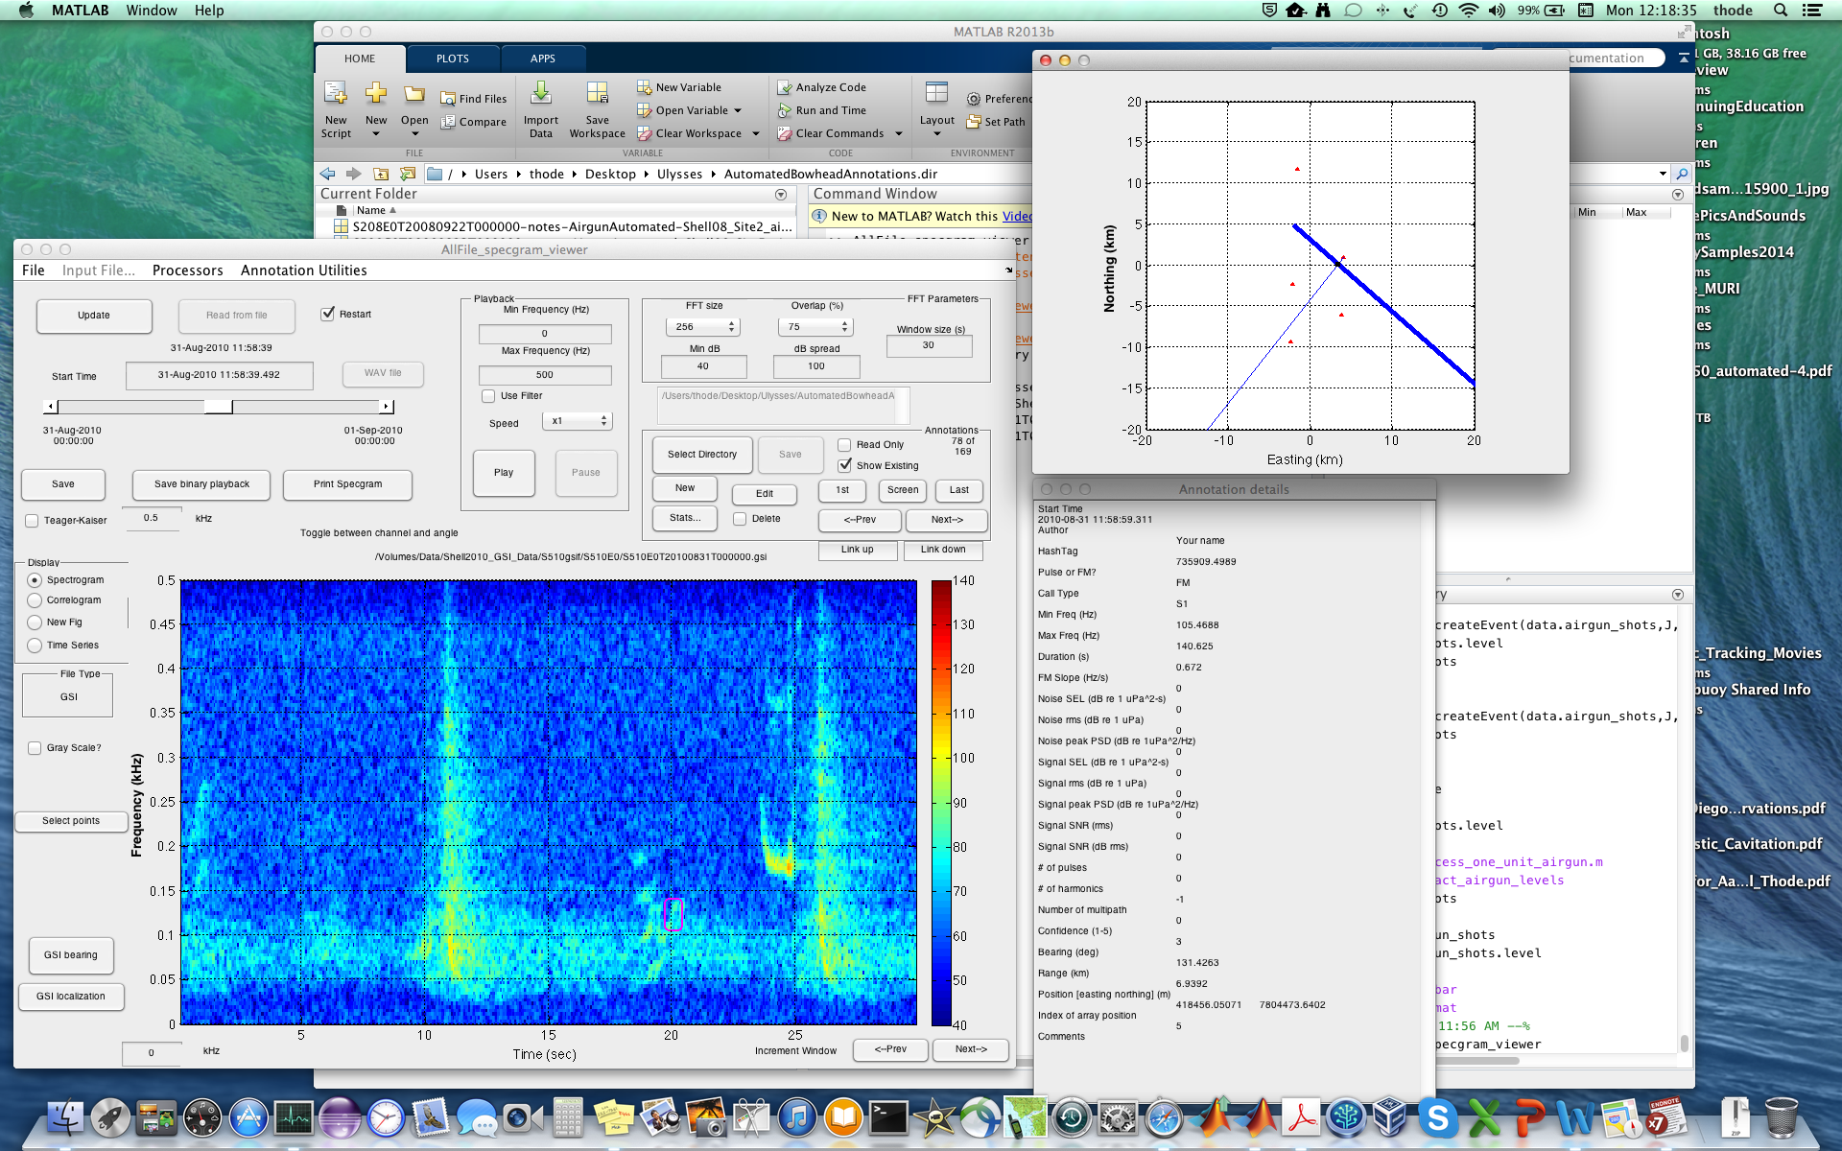

Figure 2: Ulysses display when the “Link up” button is hit.

One can move back and forth between annotations within a single file by selecting “<-Prev” and “Next->”, as with a regular annotation file. However, pressing the “Link up” and “Link down” buttons provides a new direction to move.

By hitting one of these buttons, the program “jumps” to the nearest linked annotation. It does this by saving the current annotation file, loading a new file and new annotation file, and displaying the result. Figure 2 illustrates what the Ulysses display looks like after “Link up” is selected. Note that the position of the call in the map has not changed, only the highlighted bearing changes, reflecting the fact that we are now viewing DASAR E instead of D. Note that the title above the spectrogram tells you the current title. By continuously pressing the “Link up” or “Link down” button one can cycle through all the annotations linked to this particular call.

How does this work? Each annotation has a unique ID called a “hashtag”. Whenever you create a new annotation, a new hashtag can be created, or a hashtag belonging to another annotation can be copied. If two annotations have the same hashtag, then that means they are part of the same call. For example, two harmonics drawn with two separate annotations can be linked with the same hashtag to indicate that they are part of the same call.

A linked annotation not only has its hashtag, but it also contains a list of other annotation files “link_names” and a list of other hashtags that allow it to locate the linked annotation on another file. In general, linked annotation files must be in the same folder.

**Goals of Analysis**

There will be three types of editing that can be performed with linked annotations: (1) Changing the bounding box of an annotation; (2) adding a harmonic to an annotation; (3) fixing an incorrect linkage between annotations, by either (3a) changing the annotation being linked, or (3b) deleting the annotation.

Let’s begin by locating the following annotation in DASAR D:

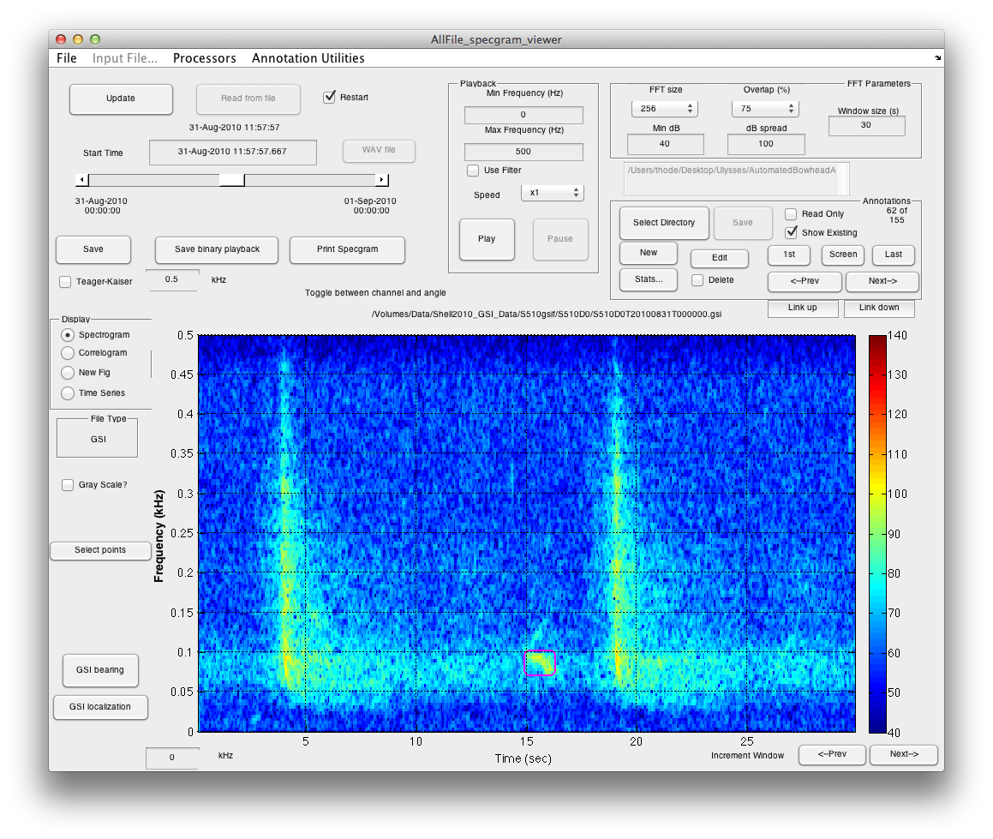

Figure 3: Annotation 62 of 155 in DASAR 5D.